Maria Saputo Monticciolo
Clinical Research Unit (CRU)


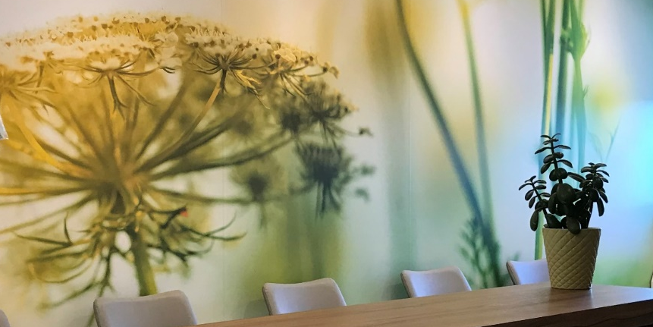

Regular clinic and office hours, by appointment
Monday- Thursday: 8h00-16h00
Friday: 8h00-15h00
Saturday-Sunday: closed
How to find us
Contact us at 514-340-8222 x24572
Where to find us
Pavilion E, 6th floor of the Segal Cancer Center

Overview
The Clinical Research Unit (CRU) was founded in 1994 and focuses on the conduct of phase I and early phase II cancer trials. The unit has successfully grown over the years and has homed to a modern facility on 6th floor of the Segal Cancer Center (SCC) in 2016.
The unit has an extensive track record of over 450 trials executed over the past 25 years, all in novel cancer therapeutics. These include a number of “first in human” trials for agents developed by academic researchers, Canadian biotech companies and international pharmaceutical industries. The research team comprised of research nurses, clinicians and coordinators, is dedicated to deliver outstanding patient care and research data. Preparation for study activation is highly efficient. Investigations carried out in the CRU are reviewed and approved by local/provincial research ethics boards. Policies and procedures are in place to adhere to Good Clinical Practice and comply with regulations set forth by Canadian and international regulatory bodies. The CRU’s contributions to advancing scientific knowledge and improving cancer care are reflected hundreds of publications.

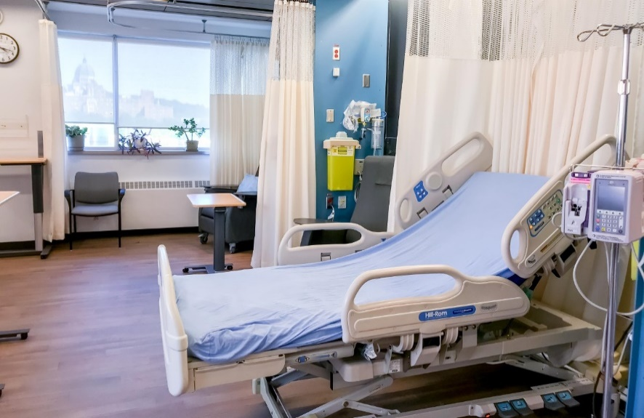
The clinic and treatment area of the unit is furnished with state-of-the-art medical equipment, including a 7-bed patient area, 12 treatment chairs and 3 single-patient rooms; all adjacent to the nursing station for continuous monitoring of patients on study. Patient treatment, follow-up and care takes place in the unit.

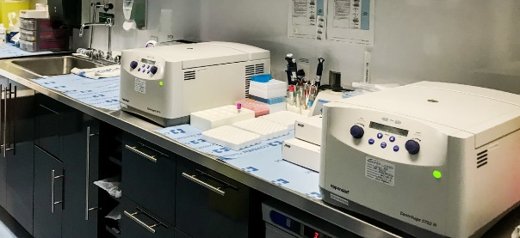
The unit also includes a laboratory area fitted with core equipment allowing for efficient collection, processing, storage and shipment of samples for pharmacokinetic and wide range of pharmacodynamics studies.

The unit can also count on highly-trained collaborators in adjacent laboratories to perform more complex sample manipulations, including tumor tissue biopsies. Throughout the years, the CRU’s collaboration with research groups affiliated with the Jewish General Hospital, including researchers of the Lady Davis Institute and of the JGH Molecular Pathology department, and other Montreal-based institutes have provided remarkable opportunities to refine precision medicine in cancer.
Services and expertise
- Translational research
- Trial planning
- Study design
- Trial coordination
- Pharmacokinetic studies
- Biobanking
- Clinical sample processing
- Trial regulatory framework
- Dedicated trial nursing
- Trial data entry
- Investigator-initiated studies
To look for clinical trials in Quebec, including trials conducted the CRU, please visit OncoQuebec.
To find out more about clinical trials, patients may consult https://itstartswithme.ca/
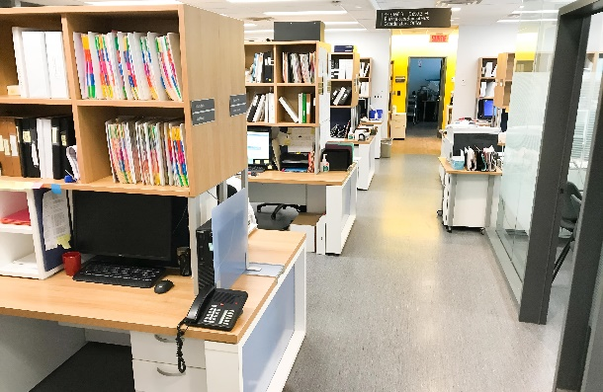
Administrative information
Director: Wilson Miller, MD, PhD
Associate Director: Sarit Assouline, MD
Unit Manager: Adele Cascini, BA
Nurse Manager: Tracy Regimbald, BScN

